Project Pinnacle
Visitor Management System (VMS)
Technical Design Document
Prepared for: CPG Corporation Pte Ltd — Westgate Tower
Prepared by: Pantropi Limited

Document control
Field | Detail
Document | Technical Design Document (TDD) — Visitor Management System (VMS)
Project | Project Pinnacle — Westgate Tower
Prepared for | CPG Corporation Pte Ltd
Prepared by | Pantropi Limited
Basis | VMS SRS v2 (96 functional requirements across four phases); phased implementation plan Revision 2
Status | Draft — proposed technical design; technology stack recommended and open to adjustment; ACS API contract pending (see Section 11)

1. Introduction

1.1 Purpose
This Technical Design Document (TDD) describes the proposed technical implementation of the Visitor Management System (VMS) for Project Pinnacle. It translates the functional and non-functional requirements in the VMS SRS v2 into an architecture, component design, data model, integration design, and deployment approach. It is intended for the development team, and for technical review by CPG Corporation and the Access Control System (ACS) vendor, Universal Automations Ltd (UAL).

1.2 Scope
This design covers the VMS application only. The ACS — flap barriers, RFID/QR reader hardware, and physical credential enforcement — is an external system integrated solely through a documented API, consistent with the SRS. Hardware, firmware, and physical installation are out of scope.

1.3 Design goals
- Clean separation between VMS and ACS, with all integration confined to a dedicated client module so ACS API changes do not ripple into core workflow logic.
- Resilience: VMS must degrade gracefully when the ACS API is briefly unavailable, without losing visitor or approval data.
- Security by design: role-based access control, authenticated integration, and a complete audit trail.
- Deployment flexibility: the same application must run either fully on-premise or in the hybrid cloud-and-edge model proposed separately, without redesign.

2. Architecture overview
VMS follows a layered, service-oriented architecture. A single-page application (SPA) front end serves all user roles; an API gateway handles authentication, authorization, and RBAC enforcement; a set of application services encapsulate the four functional domains; and a messaging and data layer provides persistence, caching, and event handling. All access-control interaction is mediated by a dedicated ACS Integration Client. The diagram below shows the logical structure.
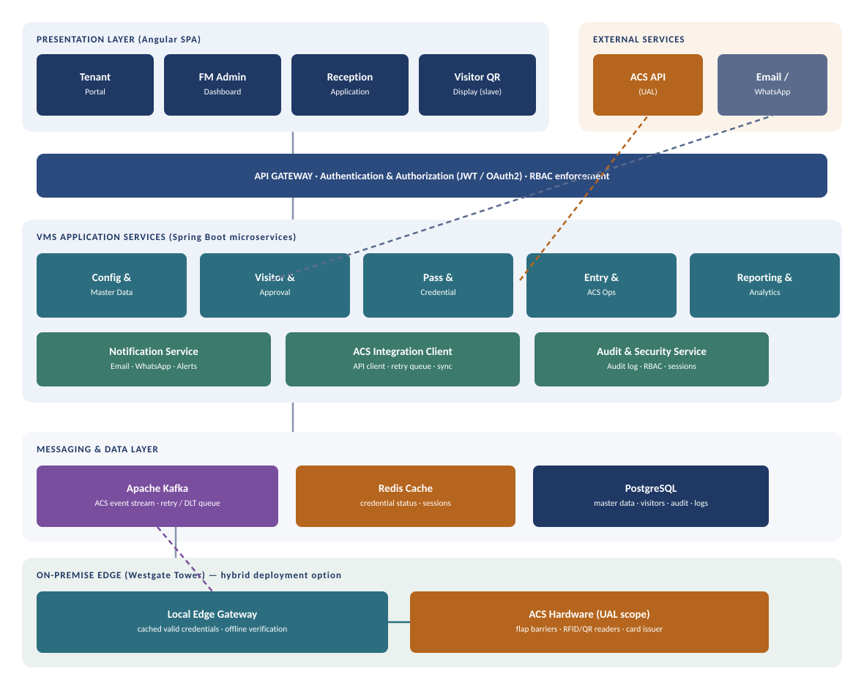
Figure 1 — VMS logical architecture (hybrid cloud-and-edge deployment shown)
The on-premise edge band is only present in the hybrid deployment option: a local edge gateway caches currently valid credentials and can verify access at the gates even if connectivity to the cloud-hosted application is briefly lost, syncing back through Kafka once restored. In a fully on-premise deployment, the application and edge collapse onto the same local infrastructure.

3. Technology stack (recommended)
The stack below is recommended based on the team's core competency and the system's needs; individual choices can be substituted without changing the architecture.
Layer | Technology | Rationale
Front end | NextJS | Single codebase serving tenant, admin, reception, and display views with role-driven routing
Back end | Java + Spring Boot (service-oriented) | Mature ecosystem for secured REST services, scheduling, and integration; aligns with team expertise
API security | Spring Security with JWT / OAuth2 | Stateless authentication and fine-grained RBAC at the gateway
Primary database | PostgreSQL | Relational integrity for master data, visitors, credentials, and audit records
Cache | Redis | Low-latency credential-status lookups and session storage
Messaging / events | Apache Kafka (with dead-letter topic) | Reliable handling of the ACS event stream and the API retry queue; natural fit for at-least-once event processing
Reporting / export | Server-side report generation to Excel and PDF | Satisfies FR-EXP-01 for the reporting suite
Deployment | Containerized (Docker), orchestrated (Kubernetes) in cloud; single-host container runtime on-premise | Same artifacts across both deployment models

4. Component / service design
Application services map one-to-one to the four SRS functional areas, plus three cross-cutting services. Each owns its data and exposes internal REST APIs behind the gateway.

4.1 Configuration & Master Data Service
Owns application configuration, branding, and all master data entities (Building, Floor, Tenant, Reception, Visitor Types, Pass Types, Holiday Calendar). Implements FR-CFG-01 to FR-CFG-08. Master data is referenced by every downstream service, so it is cached in Redis and changes are published for cache invalidation.

4.2 Visitor & Approval Service
Handles visitor requests, the approval workflow, pre-registration, appointment management, and host management (FR-VMS-01 to FR-VMS-06). Produces the confirmed-appointment event that triggers pass generation.

4.3 Pass & Credential Service
Generates passes by calling the ACS Integration Client to create credentials, storing the returned credential reference, and managing the pass lifecycle — printing/display, cancellation, and expiry (FR-VMS-07 to FR-VMS-16). It never talks to ACS directly; it calls the integration client.

4.4 Entry & ACS Operations Service
Manages the live visit lifecycle: entry and arrival verification, express entry, activation/deactivation, card issue/return/reconciliation, access/exit event processing, ACS synchronization, manual override, and visitor status tracking (FR-ENT-01 to FR-ENT-10, FR-CRD-01 to FR-CRD-03). It consumes ACS events from Kafka and updates visitor status.

4.5 Reporting & Analytics Service
Produces the reporting suite, analytics dashboard, and exports (FR-REP-01 to FR-REP-07, FR-ANL-01, FR-EXP-01), reading from VMS data plus ACS-sourced events already persisted by the Entry service.

4.6 Cross-cutting services
- Notification Service — email, WhatsApp, host, reminder, exit notifications and system alerts (FR-NOT-01 to FR-NOT-05, FR-NTF-01/02).
- ACS Integration Client — the single choke-point for all ACS API calls, embedding authentication, the retry queue, error handling, and status queries (FR-API-01 to FR-API-05). Detailed in Section 6.
- Audit & Security Service — RBAC evaluation, session handling, and the append-only audit log (FR-USR-02, FR-AUTH-01/02, FR-AUD-01/02).

5. Data model (key entities)
The core relational entities and their relationships are summarized below. Access and exit events, and physical credential state, are owned by ACS and retrieved via API rather than treated as the VMS system of record.
Entity | Key attributes | Relationships
MasterData (per type) | id, type, code, name, parent_id, active | Floor → Building; Reception → Floor; referenced by Visitor, Pass
User | id, username, role_id, reception_id, status | belongs to Role; optionally linked to a Reception
Role / Permission | role_id, name; permission_id, action | many-to-many Role↔Permission (RBAC)
VisitorRequest | id, tenant_id, host_id, requested_window, status | belongs to Tenant, Host
Visitor | id, request_id, name, contact, appointment_window, credential_ref, status | belongs to VisitorRequest; has one Credential reference
Pass / Credential ref | id, visitor_id, type (QR/RFID), acs_credential_id, validity_window, restriction (time/one-time), state | belongs to Visitor; acs_credential_id links to ACS
CardIssuance | id, visitor_id, acs_card_id, issued_at, returned_at, issuer_user_id | belongs to Visitor
AuditLog | id, user_id, action, entity, before, after, timestamp | references User
NotificationLog | id, recipient, channel, type, sent_at, delivery_status | references Visitor / Host

6. ACS integration design
The ACS Integration Client is the most design-sensitive component, because a physical action (issuing a working pass) depends on a remote call succeeding. It exposes a small internal interface to the rest of VMS and hides all ACS-specific detail.

6.1 Operations
Operation | Direction | Trigger | Notes
createCredential | VMS → ACS | Confirmed appointment (Pass Service) | Returns acs_credential_id; validity + restriction in payload
deactivateCredential | VMS → ACS | Expiry, cancellation, or override | Idempotent; safe to retry
queryCredentialStatus | VMS → ACS | On-demand check / sync job | Cached briefly in Redis
manualOverride | VMS → ACS | Administrator action | Forced state change; audited — see Section 11
consumeAccessExitEvents | ACS → VMS | Gate scans | Delivered to Kafka; drives status + alerts
consumeCardEvents | ACS → VMS | Card issuer swipe | Drives reconciliation

6.2 Reliability pattern
- Outbound calls (create/deactivate/override) are wrapped in a retry policy with exponential backoff; on repeated failure the request lands in a Kafka retry topic and the receptionist is notified that issuance is pending (FR-API-03).
- A dead-letter topic captures requests that exhaust retries, for administrator review via a system alert (FR-NOT-05).
- Inbound ACS events are processed at-least-once; handlers are idempotent, keyed on the ACS event/credential id, so a redelivered event does not double-update visitor status.
- A periodic synchronization job (FR-ENT-08) reconciles VMS state against ACS to heal any missed events.

6.3 Authentication
VMS authenticates to the ACS API using a service credential (API key or OAuth2 client credentials, per what UAL supports), stored in a secrets manager and never in source or the database (FR-API-02). All requests and responses are logged for audit and troubleshooting (FR-API-04).

7. Security design
- Authentication: stateless JWT issued on login; short-lived access tokens with refresh (FR-AUTH-01).
- Authorization: RBAC evaluated at the API gateway against the role/permission model; every service call carries the authenticated principal (FR-USR-02, FR-AUTH-02).
- Audit: all configuration changes, credential lifecycle actions, and manual overrides are written to an append-only audit log (FR-AUD-01), surfaced as an audit report (FR-REP-06).
- Data protection: visitor personal data encrypted in transit (TLS) and at rest; hosting region and data-residency posture to be confirmed before any cloud component is finalized (SRS NFR — Compliance).
- Secrets: ACS API credentials and notification-gateway keys held in a secrets manager, not in configuration files.

8. Notification design
The Notification Service is event-driven: it subscribes to domain events (credential issued, visitor approved, checked in, checked out, appointment upcoming) and dispatches through configured channels. Email is the default channel and is available from day one; WhatsApp is activated once the Business API is approved (SRS Appendix B, Item 2). Delivery status is recorded in the notification log, and delivery failures raise system alerts.
Event | Notification | Channel(s) | Requirement
Credential issued | Confirmation + QR + welcome | Email / WhatsApp | FR-NOT-01
Visitor approved / in / out | Host notification | Email / WhatsApp | FR-NOT-03
Appointment upcoming | Reminder | Email / WhatsApp | FR-NOT-04
Exit event received | Exit alert to host + visitor | Email / WhatsApp | FR-NOT-02
API failure / discrepancy | System alert to admins | Email / in-app | FR-NOT-05

9. Deployment design

9.1 Hybrid cloud-and-edge (recommended)
The application services, database, cache, Kafka, and reporting run in the cloud. A local edge gateway at Westgate Tower holds a synced set of currently valid credentials and performs real-time verification at the gates, so physical access continues during a brief loss of connectivity and resynchronizes automatically afterwards. This matches the separately proposed cloud architecture and keeps VMS independently deployable from ACS.

9.2 Fully on-premise (alternative)
All components run on local infrastructure at Westgate Tower, with no cloud dependency. This mirrors the vendor's current assumption in R2. The application design is identical; only the hosting target and the presence of the edge component differ.

9.3 Environments
- Development, staging, and production environments, with the ACS integration pointed at an ACS test endpoint in non-production.
- Containerized artifacts promoted unchanged across environments; configuration injected per environment.

10. Non-functional design considerations
Concern | Design response
Performance | Credential-status reads served from Redis; ACS create/deactivate calls kept synchronous only where a receptionist waits, otherwise queued
Reliability | Retry queue + dead-letter topic + idempotent event handlers + periodic sync job
Availability | VMS remains usable for registration/approval even if ACS is briefly unreachable; issuance is queued
Scalability | Stateless services scale horizontally; Kafka partitions the event load; sized for 300-500 visitors/day and 120 reception users
Maintainability | ACS specifics isolated in one client module; master data externalized rather than hard-coded
Observability | Centralized logging of API calls, events, and notification delivery; audit log for security review

11. Open technical dependencies
The following must be resolved for this design to be implemented as specified. Each corresponds to an open item already tracked in the SRS.
The single most important dependency is the detailed ACS API contract from UAL — endpoints, authentication method, payload schema, and error codes. Section 6 is designed around this contract existing; until it is provided, the ACS Integration Client can be scaffolded against an interface but cannot be completed or tested against the real system.
# | Dependency | Impact if unresolved
1 | Detailed ACS API contract (SRS Appendix B, Item 4) | Blocks completion of the ACS Integration Client (Section 6) and all credential operations
2 | ACS support for Express Entry — recognizing VMS-issued credentials without reception mediation (SRS Appendix B, Item 1) | Determines whether FR-ENT-03 is achievable as designed; affects the Entry service
3 | ACS support for Manual Override — administrative forced state change (SRS Appendix B, Item 5) | Determines whether the manualOverride operation (Section 6.1) is possible or needs a physical fallback
4 | WhatsApp Business API approval (SRS Appendix B, Item 2) | WhatsApp channel in the Notification Service stays inactive until approved; email proceeds regardless
5 | Cloud hosting region + data residency confirmation | Required before the hybrid deployment (Section 9.1) can be finalized

